*A project report on*

**Development of web application using HTML & CSS for**

**HOSPITAL-PATIENT MANGEMENT SYSTEM.**

*Submitted in partial fulfilment for the award of the degree of*

**Master of Technology in Software Engineering**

*by*

**<NAME><NUMBER>**



**AMARAVATI**

**School of M.Tech Integrated Software Engineering**

May, 2019



**AMARAVATI**

**MTSE**

May, 2019

**CERTIFICATE**

This is to certify that the thesis entitled “Development of web application using HTML & CSS for **HOSPITAL PATIENT MANAGEMENT SYSTEM**”. Submitted by <NAME><NUMBER>, M.Tech Software Engineering, School of CSE VIT-AP, for the award of the Summer Internship for the bonafide work carried out by her under my supervision.

The contents of this report have not been submitted and will not be submitted  
either in part or in full, for the award of any other degree or diploma in this institute or  
any other institute or university. The Project report fulfils the requirements and regulations of  
VIT-AP and in my opinion meets the necessary standards for submission.

**Signature of the Guide**  **Signature of the Dean**

**ABSTRACT**

Hospital-Patient Management System helps to maintain patients information in the Hospital, Where the patients are taking treatment with which doctor belongs to which department. Patient management system helps to create appointment to consult doctor, and it helps to provide the total description of patients. This application provides the basic information about doctors, patients, administrators, reception and the bill payments of patient and the prescription of patient given by the doctor to the patient.

**ACKNOWLEDGEMENT**

It is my pleasure to express with deep sense of gratitude to **Prof. K.Hari Kishan**, for his constant guidance, continual encouragement, understanding more than all. He taught me patience in my endeavour. My association with him is not confined to academics only, but it is a great opportunity on my part of work with an intellectual and expert in the field of software.

I would like to express my gratitude to **Mr. G.Vishwanathan**(Chancellor),**Dr.Hari Seetha** (Dean of CSE), **Mr. Sankar Viswanathan**(vice president) and School of CSE for providing with an environment to work in and for his inspiration during the tenure of the course.

In jubilant mood I express ingeniously my whole-hearted thanks to the Program Chair and all teaching staff and members working as limbs of our university for their non self-centred enthusiasm coupled with timely encouragements showered on me with zeal, which prompted the acquirement of the requisite knowledge to finalize my course study successfully. I would like to thank my parents for their support.

It is indeed a pleasure to thank my friends who encouraged me to take up and complete this task. At last but not least, I express my gratitude and appreciation to all those who have helped me directly or indirectly toward the successful completion of this project.

Place: Amaravathi <NAME>.

Date:18-05-2019 Name of the student

**Table of Contents**

1. INTRODUCTION-----------------------------------------------------------6
   1. ABSTRACT----------------------------------------------------------6
2. PROBLEM DEFINITION--------------------------------------------------7
3. SYSTEM ANALYSIS-------------------------------------------------------8
   1. EXISTINGSYSTEM-------------------------------------------------8
   2. PROPOSED SYSTEM-----------------------------------------------8
4. FEASIBILITY STUDY-----------------------------------------------------9
   1. TYPES OF FEASIBILITY------------------------------------------9
5. PROJECT OVERVIEW-----------------------------------------------------11
   1. PROJECT MODULES-----------------------------------------------11
6. DEFINITION, ACRONYMS AND ABBREVATIONS----------------13
7. SYSTEM REQUIREMENTS-----------------------------------------------14
   1. SOFTWARE REQUIREMENTS-----------------------------------14
   2. HARDWARE REQUIREMENTS----------------------------------14
8. SYSTEM DESIGN-----------------------------------------------------------15
9. SCREENS---------------------------------------------------------------------21
10. DATABASE DESIGN-------------------------------------------------------33
11. TEST REPORT, TEST PLAN----------------------------------------------37
12. CONCLUSION----------------------------------------------------------------43
13. **INTRODUCTION**

Patient Management System helps to maintain total patients in the Hospital.Patient records management system is a comprehensive patient care related clinical information system meant for doctors to enable quick review of previous medical history of patients and provide better quality treatment to the patients.

**1.1 ABSTRACT:**

**Project Analysis:**

This application consists of following modules

1. Registration Module
2. Patient Scheduling Module
3. Doctor Module
4. Admin Module
5. Reception Module

**Module I:**  Registration module consists of sub modules namely:

* Maintains New Patient Registration, Doctor Registration, Reception Registration
* Payments, Appointment Facility from Doctors, Admission

**Module II:** Out Patient scheduling module consists of sub modules namely:

* Maintains Patient Appointments and View Prescription.

**Module III:**  Doctor Module consists of sub modules namely:

* Enters the Patient Prescription and View all appointments done by the patient

**Module IV:** Admin module consists of sub modules namely:

* Provide access rights

**Module V:** Reception module consists of sub modules namely:

* Maintains Patient Appointments.
* Maintains Patient Bill Details

**2. PROBLEM DEFINITION**

In the existing system there are following disadvantages:

* The existing is a manual process.
* Here the patient’s registration is entered in the registers.
* Lots of paper work is done, which may lead to loss of information.
* The doctors may forget their appointments with the patient’s.
* There is no separate user to interact with database.
* Registration of patient’s process is manual.
* Difficult to maintain details of all staff working in the hospital and also patient’s details at the same time.

So in order to reduce all the draw backs of manual system we are going for automated system.

**3.SYSTEM ANALYSIS**

**3.1EXISTING SYSTEM:**

The existing system is a manual process. Here the patients registration is entered in the registers. Lots of paper work is done, which may lead to loss of information. The doctors may forget their appointments with the patients.

**DISADVANTAGES:**

* Doctors have to check the reports of the patients to know their previous history which consumes a lot of time.
* They have to come to the receptionist to check their daily appointments
* Registration of patient’s process is manual.
* The patient does have to wait for two or three days to get their lab reports and their total bill details.
* Difficult to maintain details of all staff working in the hospital and also patient’s details at the same time.

So in order to reduce all the draw backs of manual system we are going for automated system.

**3.2 PROPOSED SYSTEM:**

To overcome the difficulties in our existing system we use this system. The advantages of this system are:

**ADVANTAGES:**

* HPMS helps to keep a track of the patients registering in a hospital
* This system supports the accessing of the patients previous case sheets and history.
* Helps the doctors to check their appointments for the day.
* Doctors will also use the system to keep track of the patient assigned to them.
* Flexible for future enhancements.
* User friendly interfaces for data entry and easy to navigate.
* Make our work easier.
* Searching of data is easy.
* High security is provided.

**4. FEASIBILITY STUDY**

A feasibility study is an evaluation of a proposal designed to determine the difficulty in carrying out a designated task. Generally, a feasibility study precedes technical development and project implementation. In other words, a feasibility study is an evaluation or analysis of the potential impact of a proposed project.

## 4.1 TYPES OF FEASIBILITY:

### TECHNOLOGY AND SYSTEM FEASIBILITY:

### The assessment is based on an outline design of system requirements in terms of Input, Processes, Output, Fields, Programs, and Procedures. This can be quantified in terms of volumes of data, trends, frequency of updating, etc. in order to estimate whether the new system will perform adequately or not. Technological feasibility is carried out to determine whether the company has the capability, in terms of software, hardware, personnel and expertise, to handle the completion of the project.

### ECONOMIC FEASIBILITY:

### Economic analysis is the most frequently used method for evaluating the effectiveness of a new system. More commonly known as cost/benefit analysis, the procedure is to determine the benefits and savings that are expected from a candidate system and compare them with costs. If benefits outweigh costs, then the decision is made to design and implement the system. An entrepreneur must accurately weigh the cost versus benefits before taking an action.

### LEGAL FEASIBILITY:

### Determines whether the proposed system conflicts with legal requirements, e.g. a data processing system must comply with the local data protection acts.

### OPERATIONAL FEASIBILITY:

### Is a measure of how well a proposed system solves the problems, and takes advantage of the opportunities identified during scope definition and how it satisfies the requirements identified in the requirements analysis phase of system development.

### SCHEDULE FEASIBILITY:

### A project will fail if it takes too long to be completed before it is useful. Typically this means estimating how long the system will take to develop, and if it can be completed in a given time period using some methods like payback period. Schedule feasibility is a measure of how reasonable the project timetable is.

## OUTPUT:

## The feasibility study outputs the feasibility study report, a report detailing the evaluation criteria, the study findings, and the recommendations.

**5. PROJECT OVERVIEW**

**INTRODUCTION:**

This HPMS system is a self-contained system that manages activities of the hospital such operations scheduling, personal management, and administrative issues.

Patient Management System helps to maintain total patients in the Hospital. Patient records management system is a comprehensive patient care related clinical information system meant for doctors to enable quick review of previous medical history of patients and provide better quality treatment to the patients.

After login to the system there are three different actors’ administrator, doctor, receptionist.

**5.1 PROJECT MODULES:**

**ADMINISTRATOR:**

After login to the system if the user is administrator then they are allowed to perform certain activities:

* Adding & deleting information & staff.
* Viewing the staff details.
* Updating the staff.
* Viewing the patient details
* Updating and deleting the patient details.
* Viewing the patient status etc...

**DOCTOR:**

If the user is doctor then they may perform any of activities like:

* Viewing the outpatient details
* Viewing the inpatient details
* Viewing the patient health status
* Viewing the patient discharge form

**RECEPTIONIST:**

After login to the system if the user is receptionist then they are allowed to perform certain activities:

* Insert all the details in the registration form
* Insert all the details of the patients
* Insert all the details regarding patient status
* Insert all the details in the patient discharge form
* Viewing the outpatient details
* Viewing the inpatient details
* Viewing the patient health status
* Viewing the patient discharge form

**6. DEFINITIONS, ACRONYMS, ABBREVATIONS**

**HPMS –** Hospital Patient Management System

**Data Base –** Collection of information in a structured form

**Login ID –** a user identification number to enter the system

**Password –** a word that enables one to gain admission into the system

**Web-based Application –** an application that runs on the internet

**Windows –** an operating system produce by Microsoft Corporation that is used to operate the computer using GUI

**Oracle –** a query language to interrogate the system

**PID –** Patient Identification Number

**GUI –** Graphical User Interface

**DBMS (Database Management System):**

Database Management system is used to store data in the form of records (or) tables.

**HTTP**- Hyper Text Transfer Protocol

**HTML** - Hyper Text Mark-up Language

**HS** - Host System

**JSP** - Java Server Pages

**7.SYSTEM REQUIREMENTS**

* 1. **SOFTWARE REQUIREMENTS:**

|  |  |
| --- | --- |
| OPERATING SYSTEM | Windows XP Service Pack2 |
| TECHNOLOGY | JAVA/J2EE(JDBC,JSP,HTML,JSCRIPT) |
| WEB SERVER | TOMCAT 5.5 |
| DATABASE | MY SQL |
| SOFTWARE | JDK 1.6 |

* 1. **HARDWARE REQUIREMENTS:**

|  |  |
| --- | --- |
| HARDWARE | Pentium based systems with a minimum of p4 |
| RAM | 512MB(minimum) |

**8.SYSTEMDESIGN**

**UML DIAGRAMS**

**Use Case:**

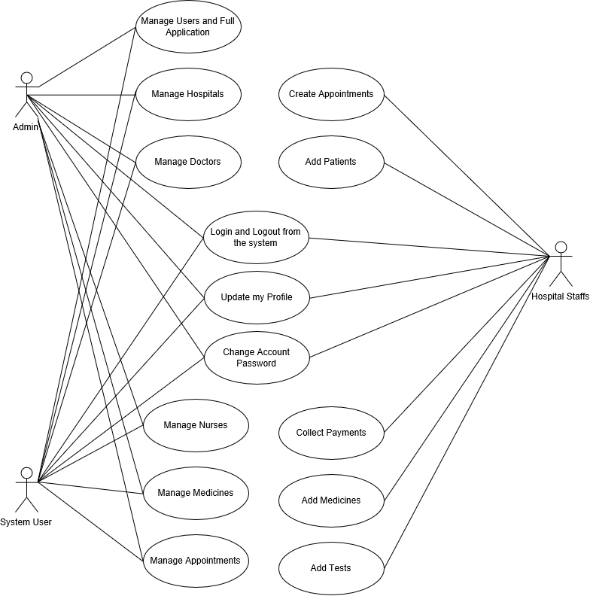

Fig:8.1 Use case diagram for Hospital Patient Management system

**Class Diagram:**

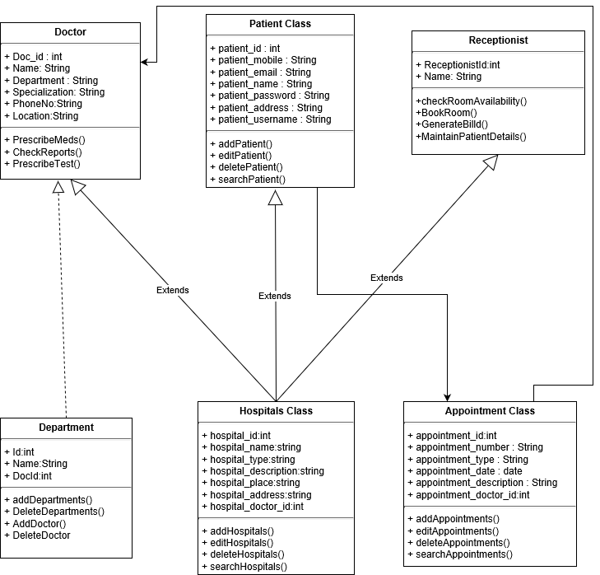

Fig:8.2 Class diagram for Hospital Patient Management system

**Activity Diagram:**

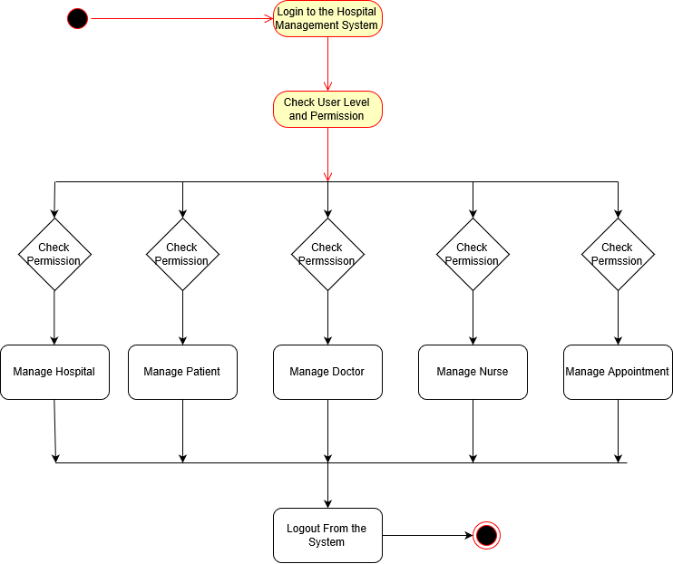

Fig:8.3 Activity diagram for Hospital Patient Management system

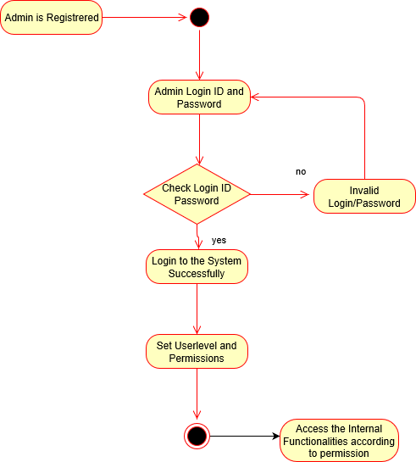

Fig:8.4 Activity diagram for Login in Hospital Patient Management system

**Sequence Diagram:**

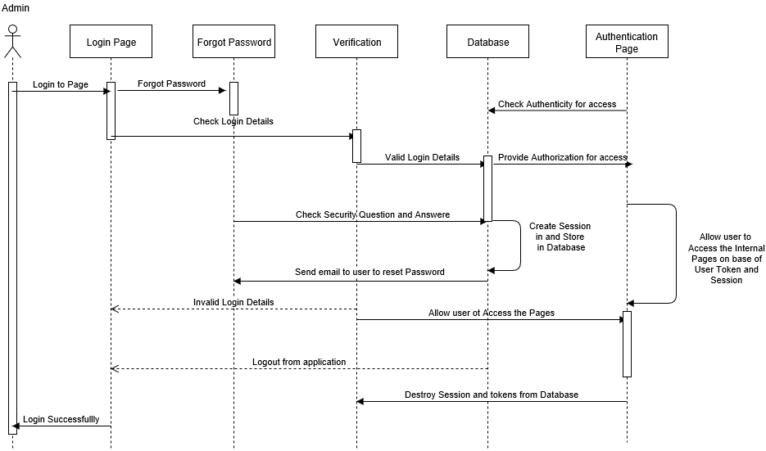

Fig:8.5 Sequence diagram for Login in Hospital Patient Management system

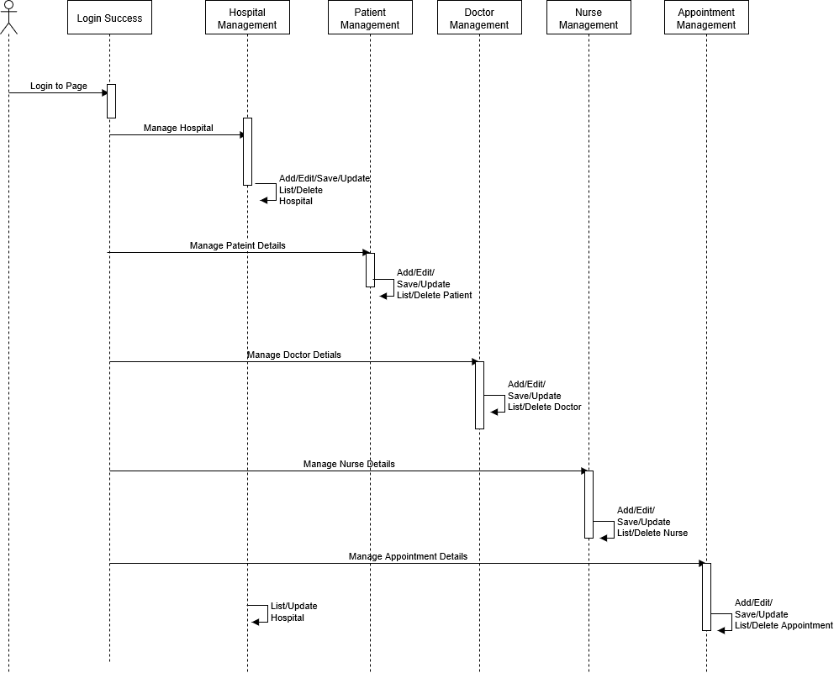

Fig:8.6 Sequence diagram for Hospital Patient Management system

**9.Graphic User Interface(SCREENS)**

**Home page:**

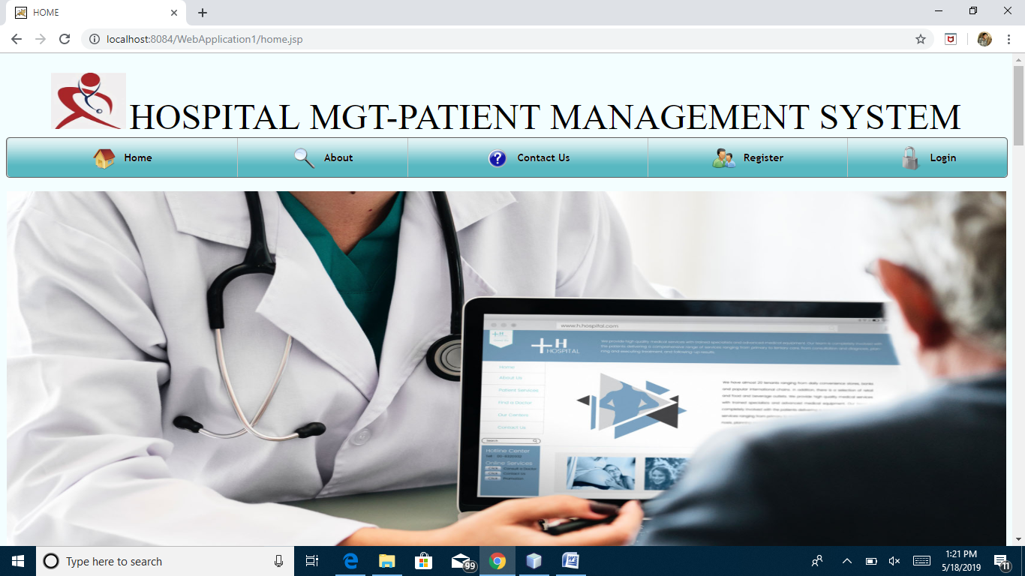

Fig:9.1 Home Page for Hospital Patient Management system

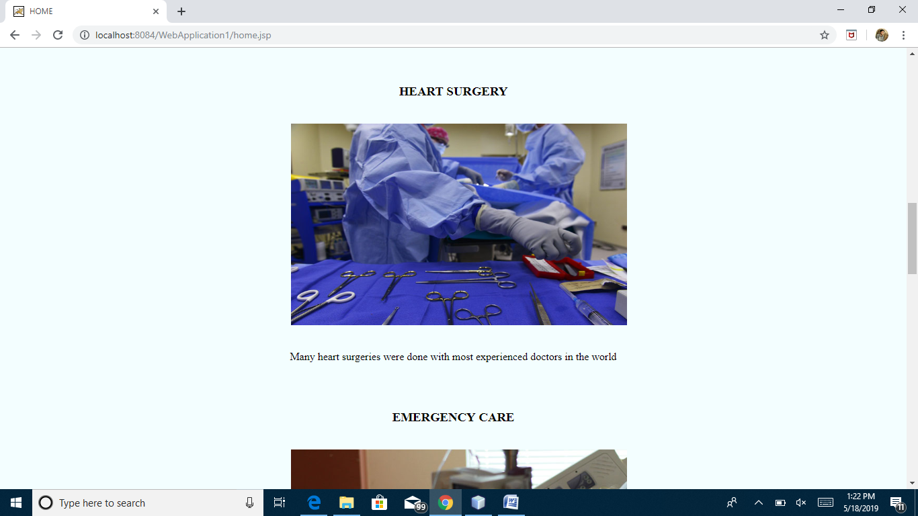

Fig:9.2 Home page for Hospital Patient Management system

**About:**

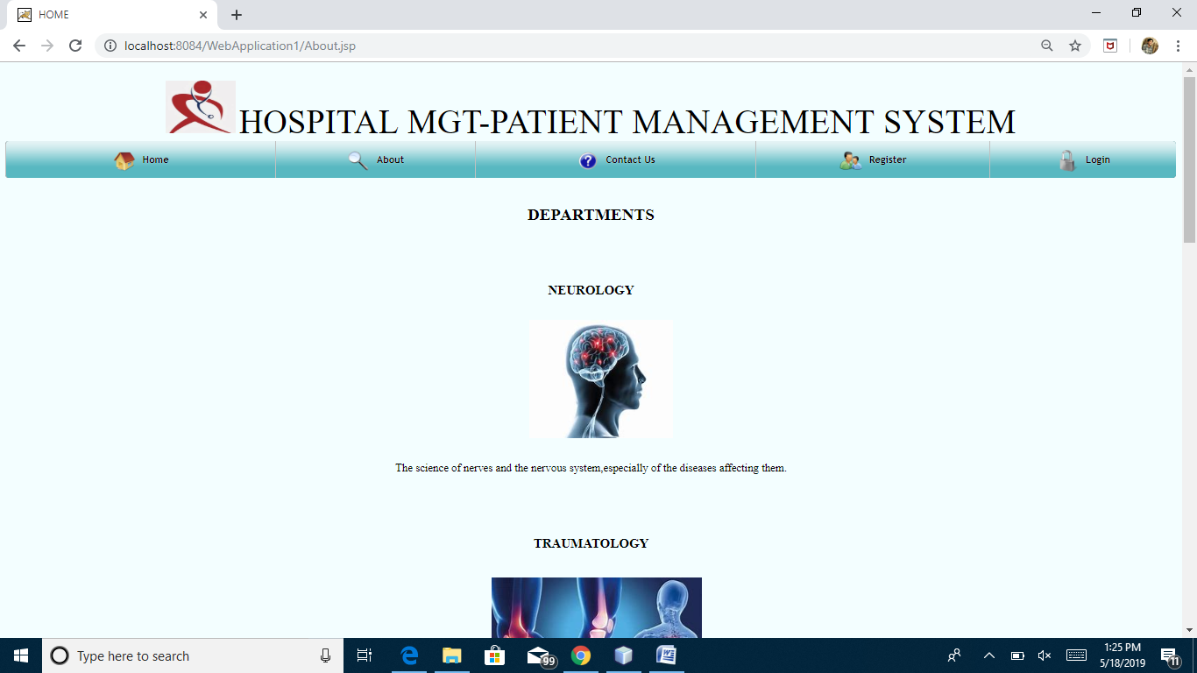

Fig:9.3 Home page for Hospital Patient Management system

**Contact Us:**

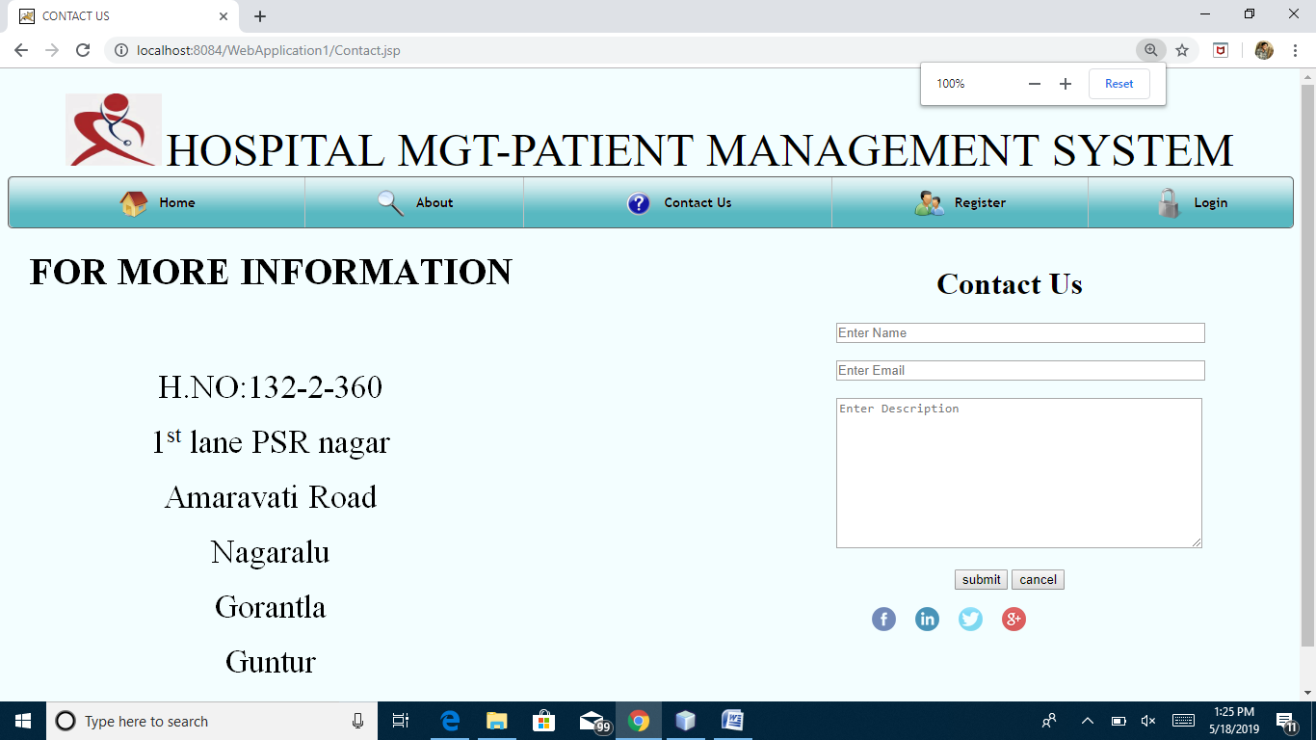

Fig:9.4 About page for Hospital Patient Management system

**Doctor registration:**

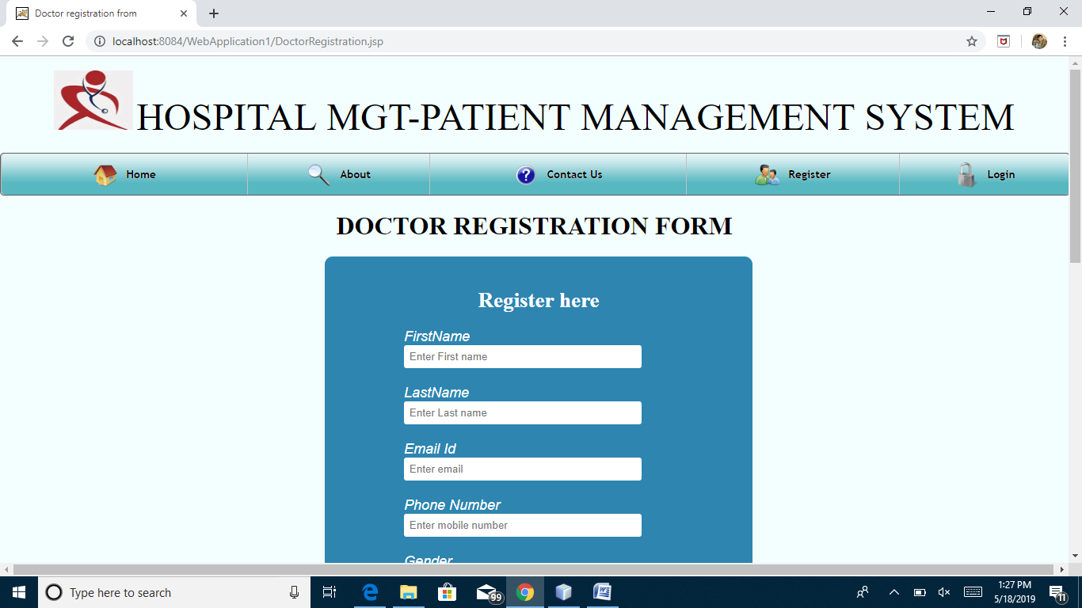

Fig:9.5 Doctor Registration page for Hospital Patient Management system

**Patient registration:**

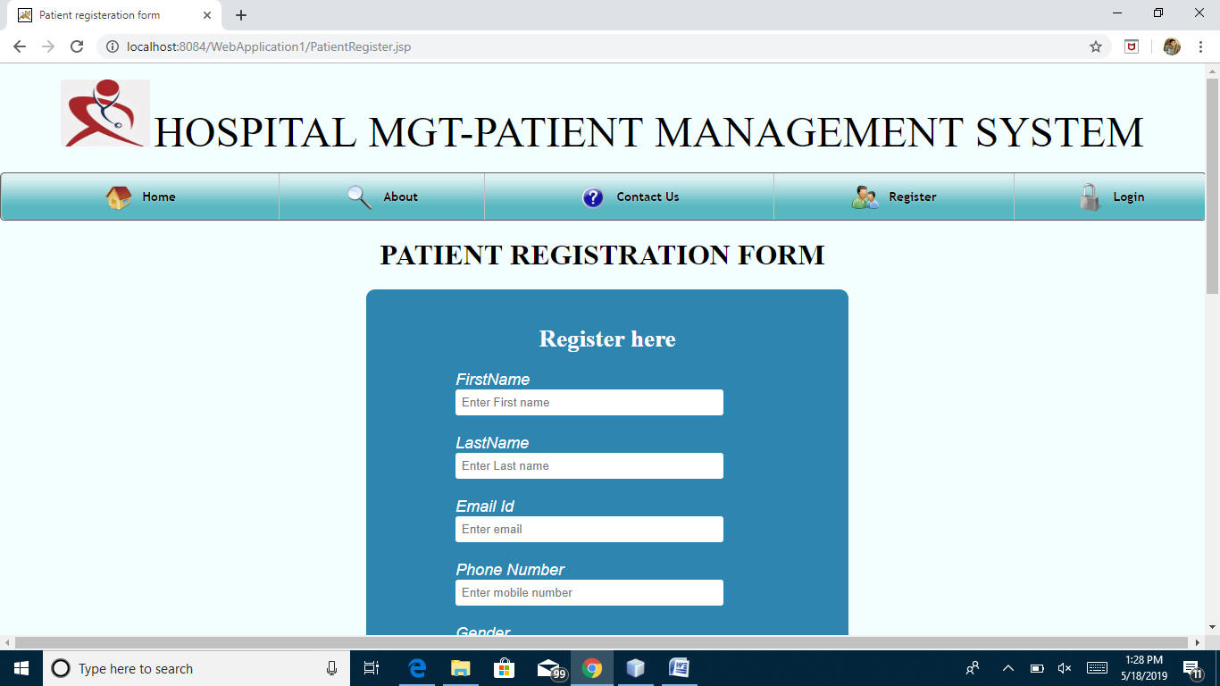

Fig:9.6 Patient Registration page for Hospital Patient Management system

**Reception Registration:**

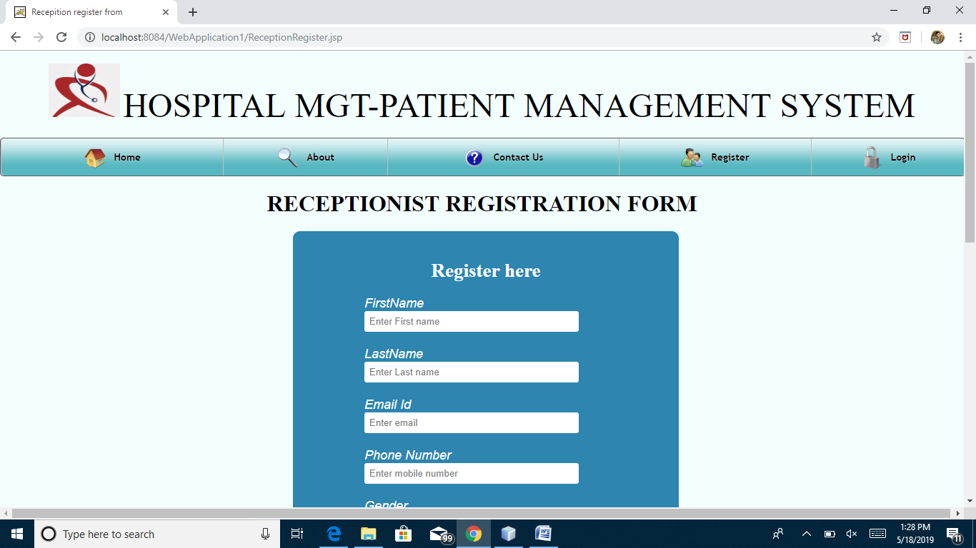

Fig:9.7 Reception Registration page for Hospital Patient Management system

**Doctor Login:**

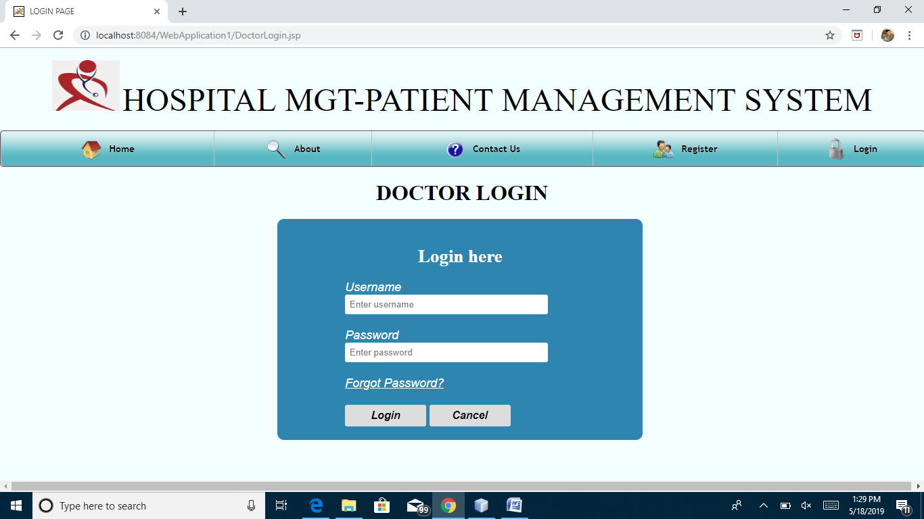

Fig:9.8 Doctor Login page for Hospital Patient Management system

**Patient Login:**

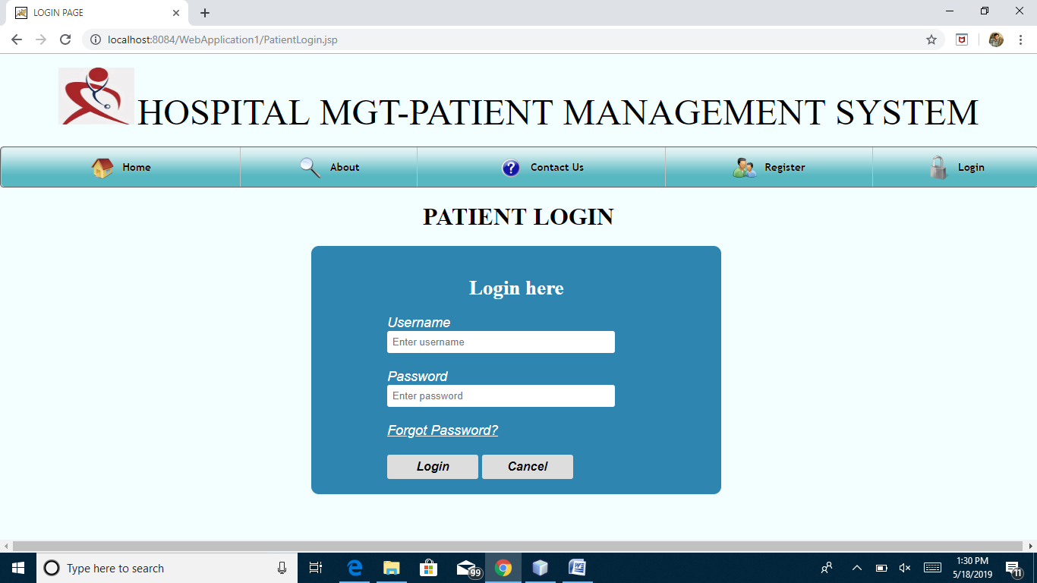

Fig:9.9 Patient Login page for Hospital Patient Management system

**Reception Login:**

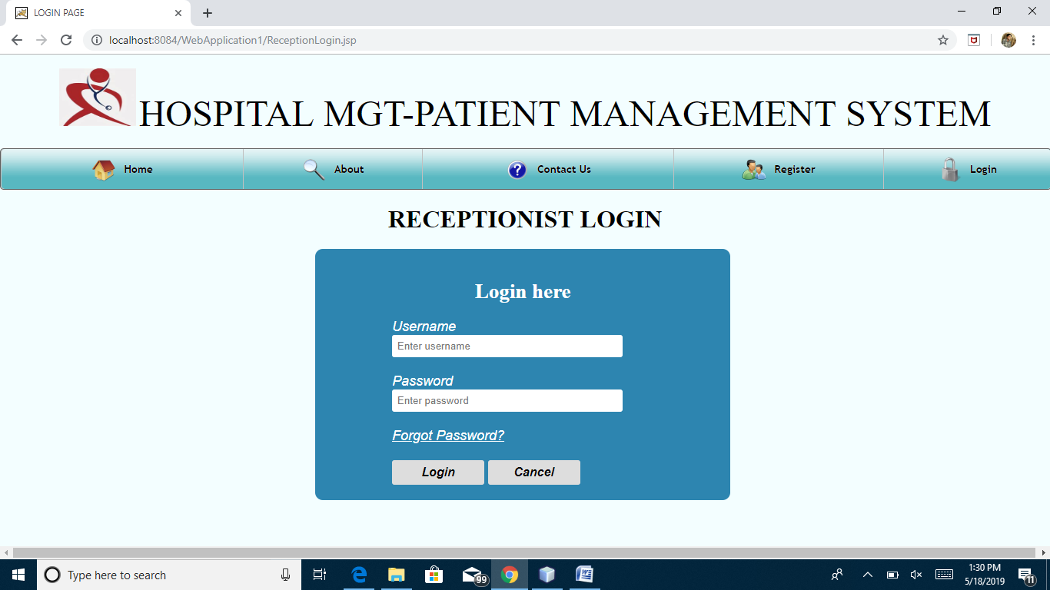

Fig:9.10 Reception Login page for Hospital Patient Management system

**Admin Login:**

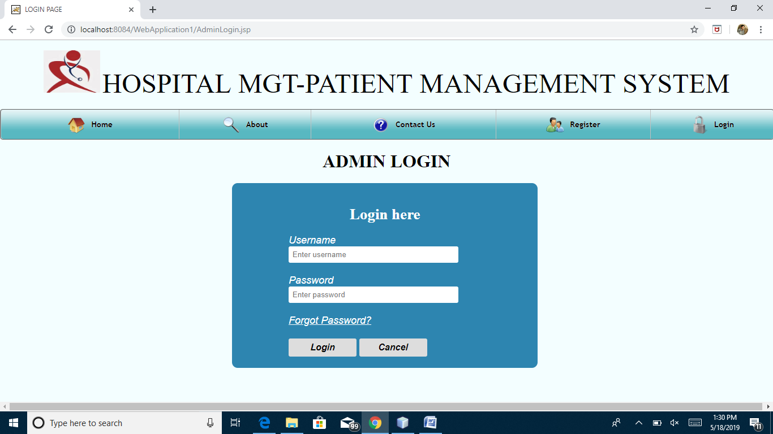

Fig:9.11 Admin Login page for Hospital Patient Management system

**Doctor profile page:**

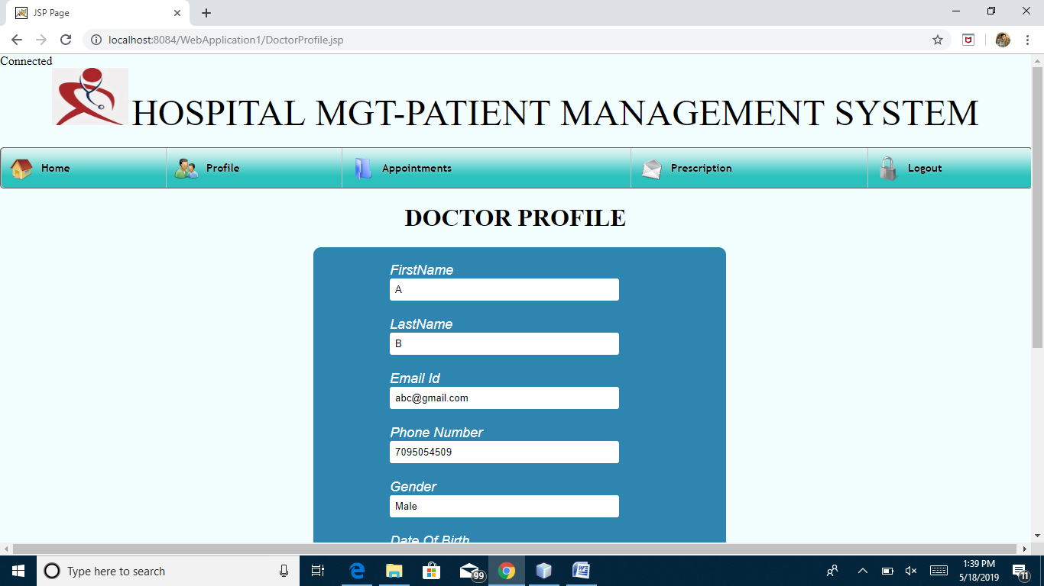

Fig:9.12 Doctor Profile page for Hospital Patient Management system

**Doctor Appointments:**

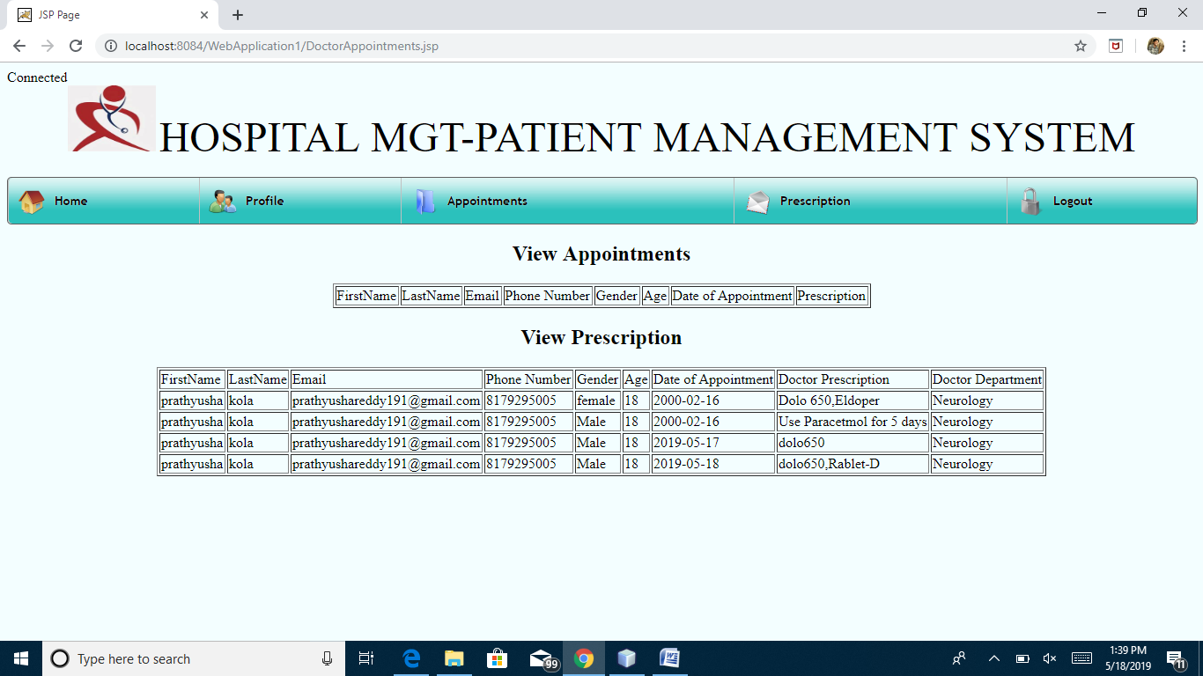

Fig:9.13 Doctors Appointments page for Hospital Patient Management system

**Doctor Prescription:**

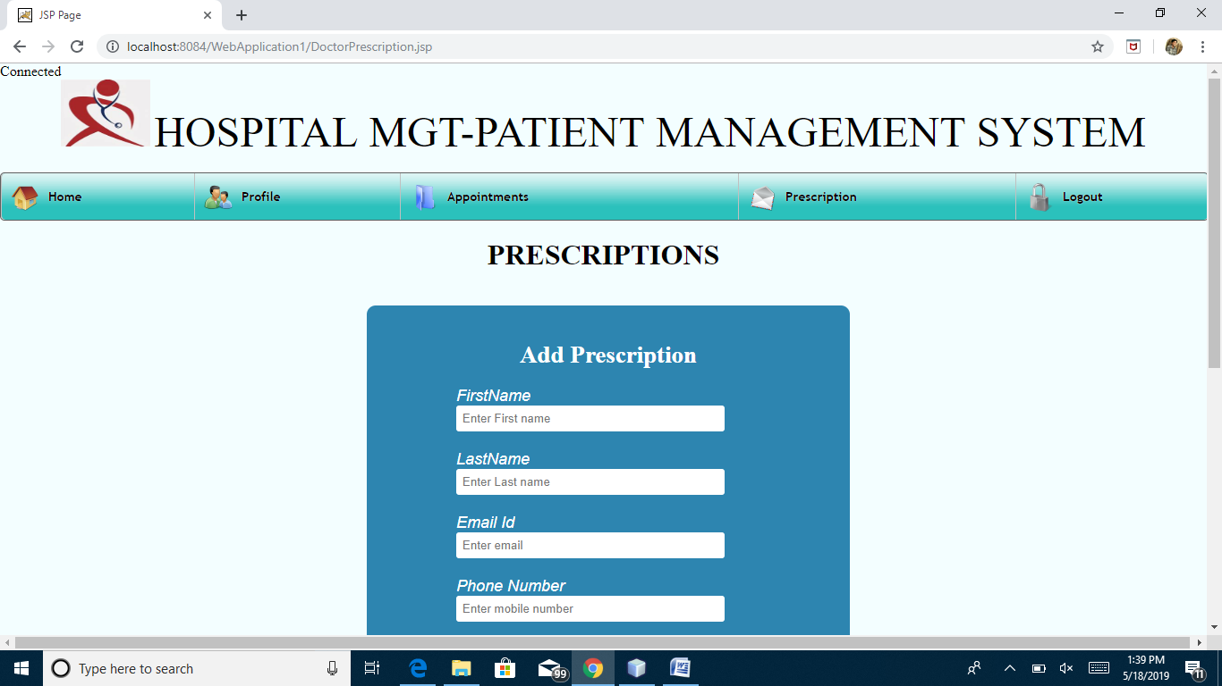

Fig:9.14 Add Prescription page for Hospital Patient Management system

**Patient Profile:**

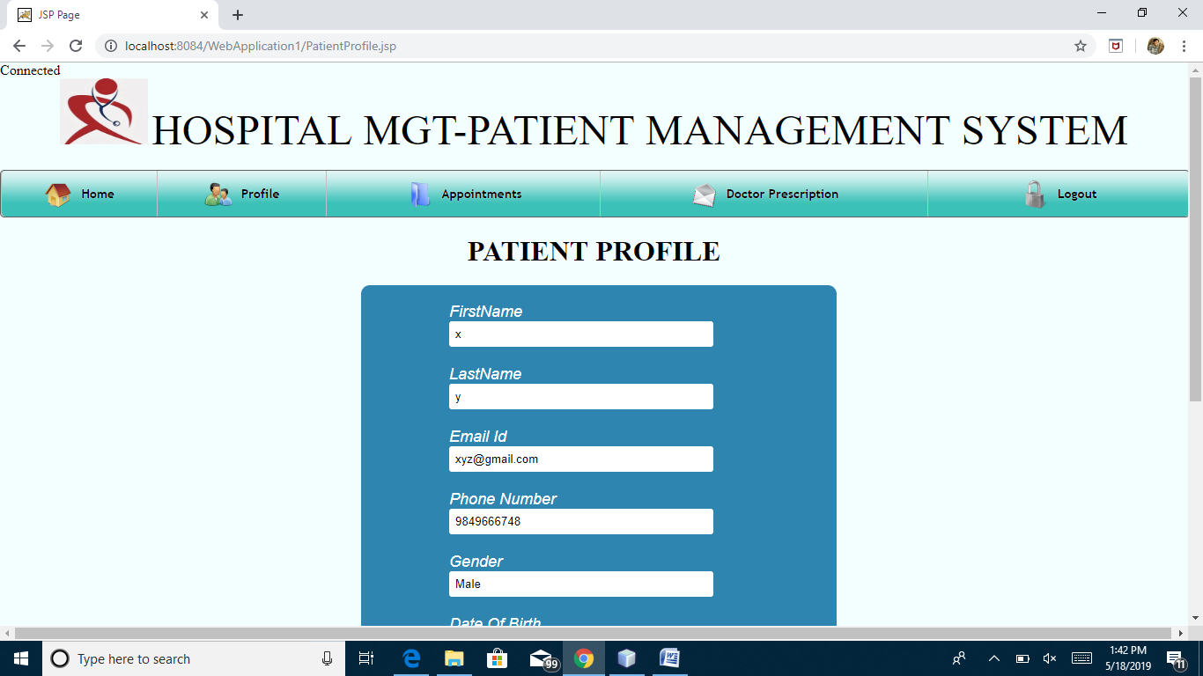

Fig:9.15 Patient Profile page for Hospital Patient Management system

**Patient Appointments:**

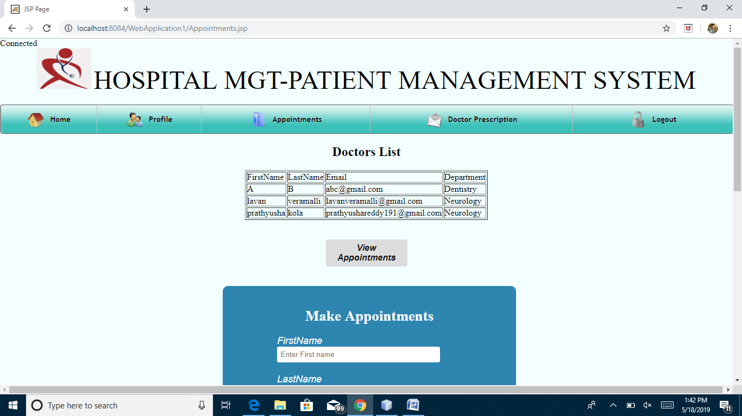

Fig:9.16 Make Doctor Appointements page for Hospital Patient Management system

**Patient Prescription:**

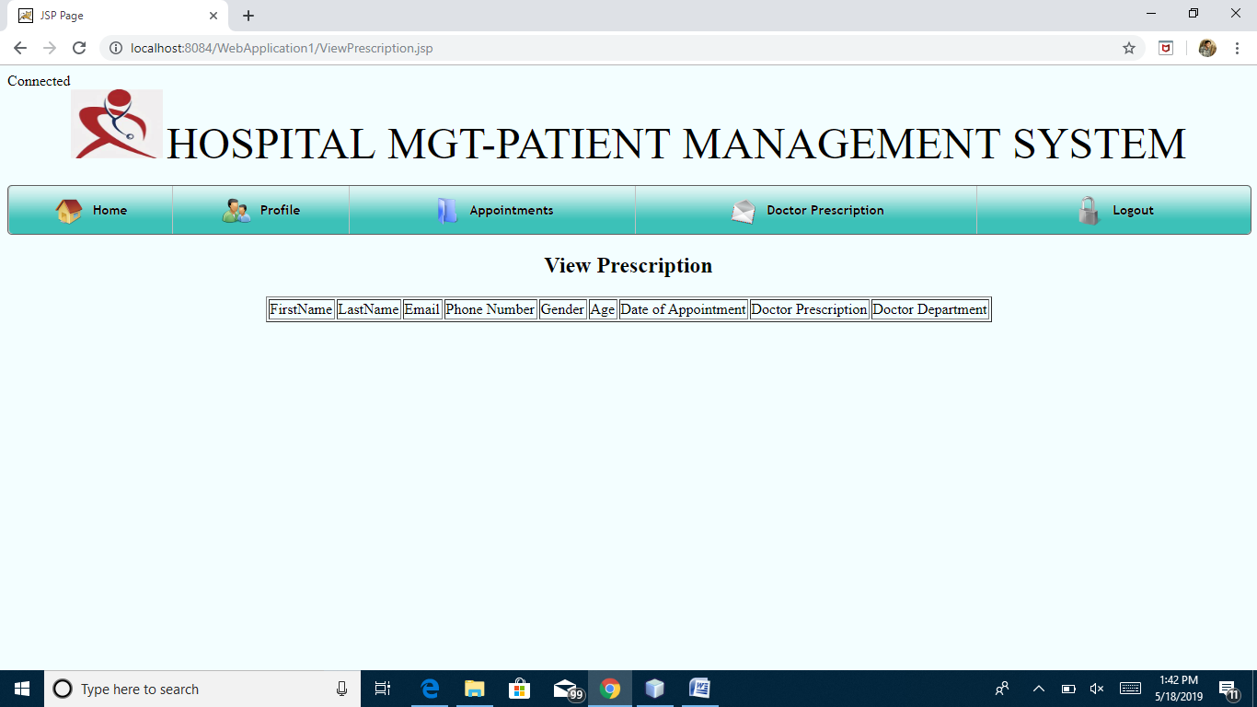

Fig:9.17 View Doctor given Prescription page for Hospital Patient Management system

**Reception Profile:**

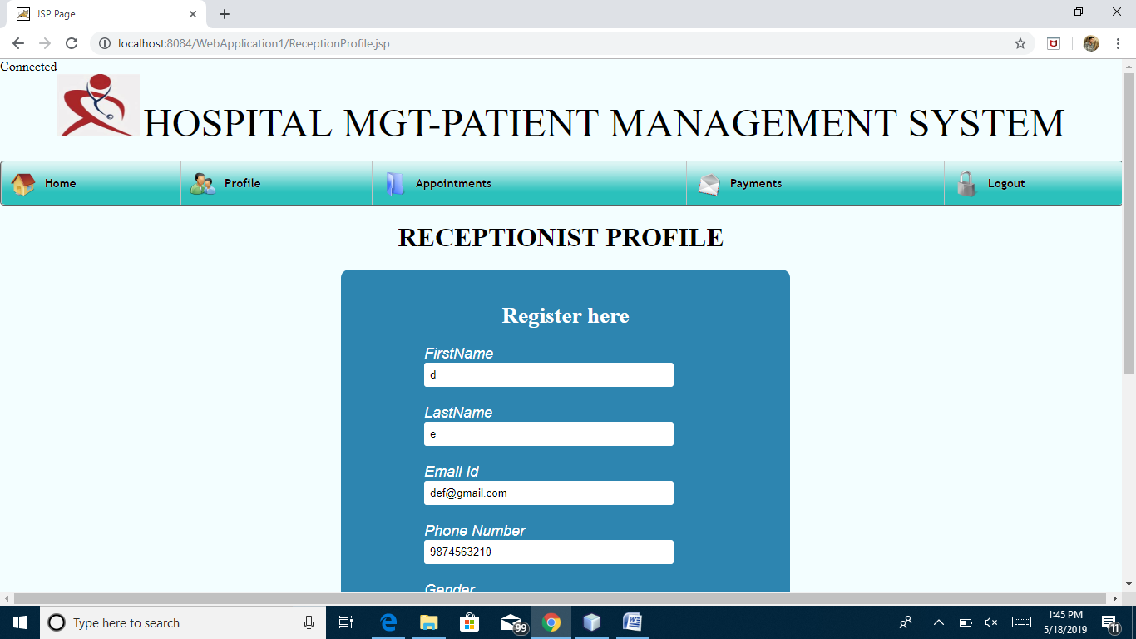

Fig:9.18 Reception Profile page for Hospital Patient Management system

**Reception Appointments:**

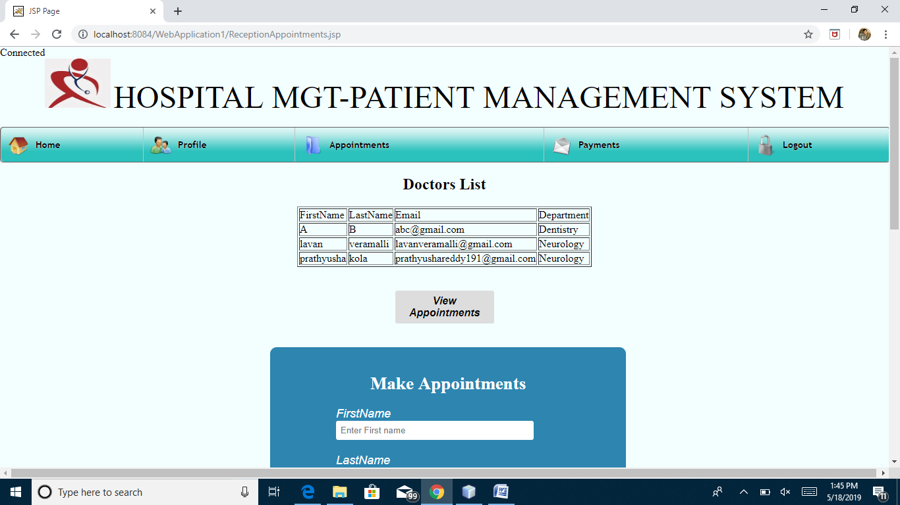

Fig:9.19 Receptionist Appointments page for Hospital Patient Management system

**Reception Payments:**

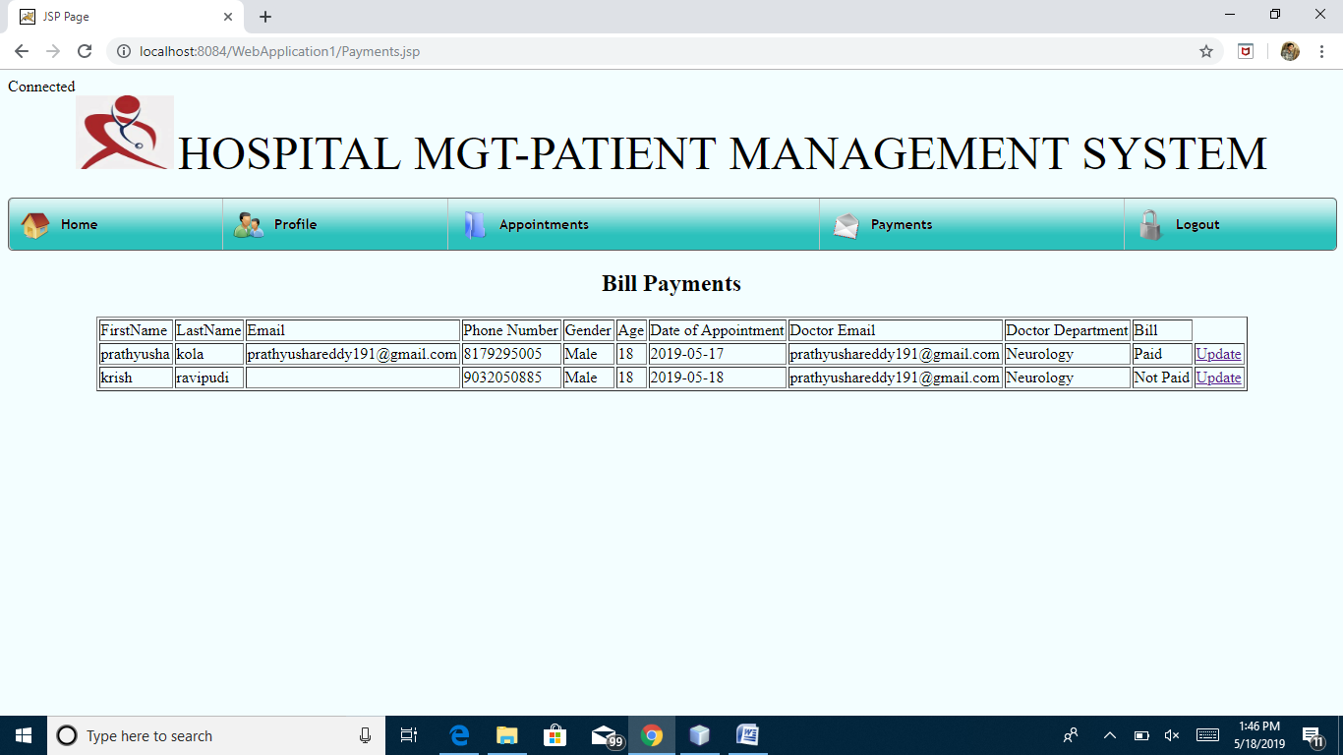

Fig:9.20 Reception Bill Payments page for Hospital Patient Management system

**Admin Profile:** He can view all the registred profile in this web application.

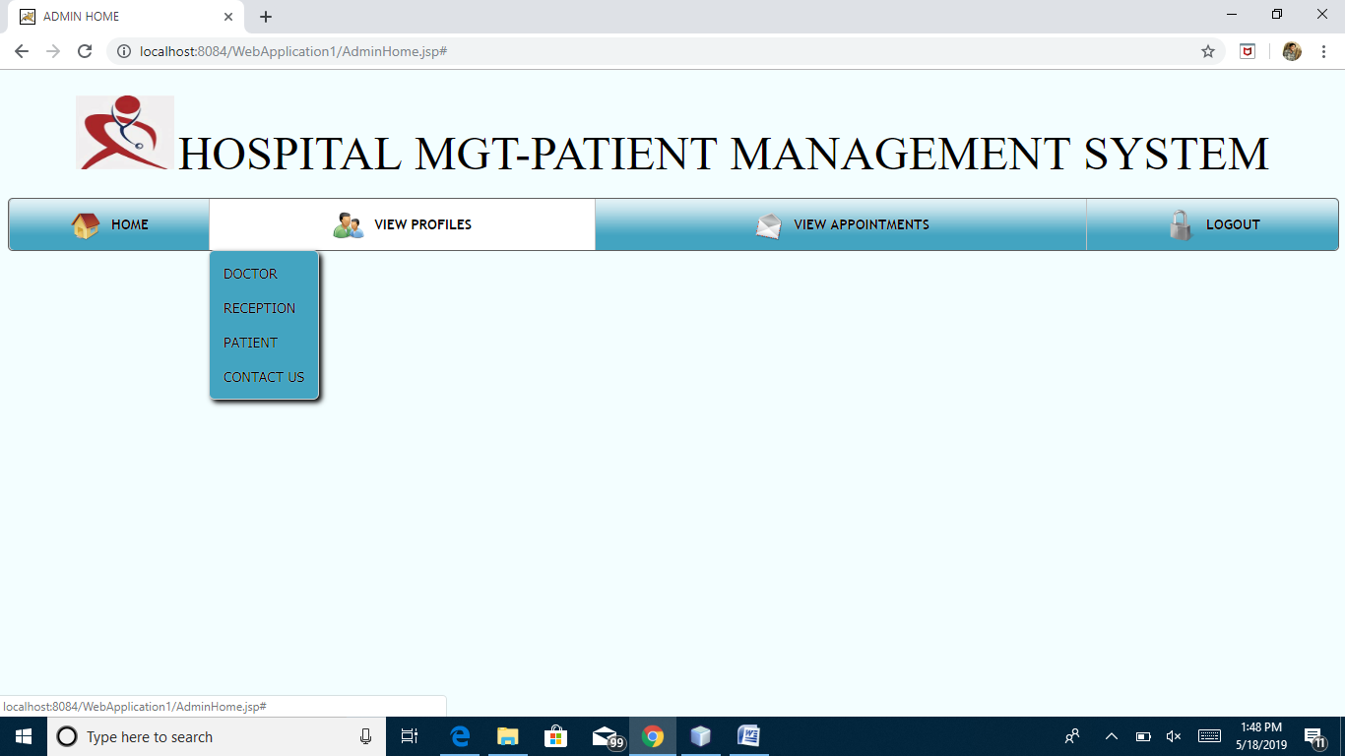

Fig:9.21 Admin Profile page for Hospital Patient Management system

**Admin Appointments:**

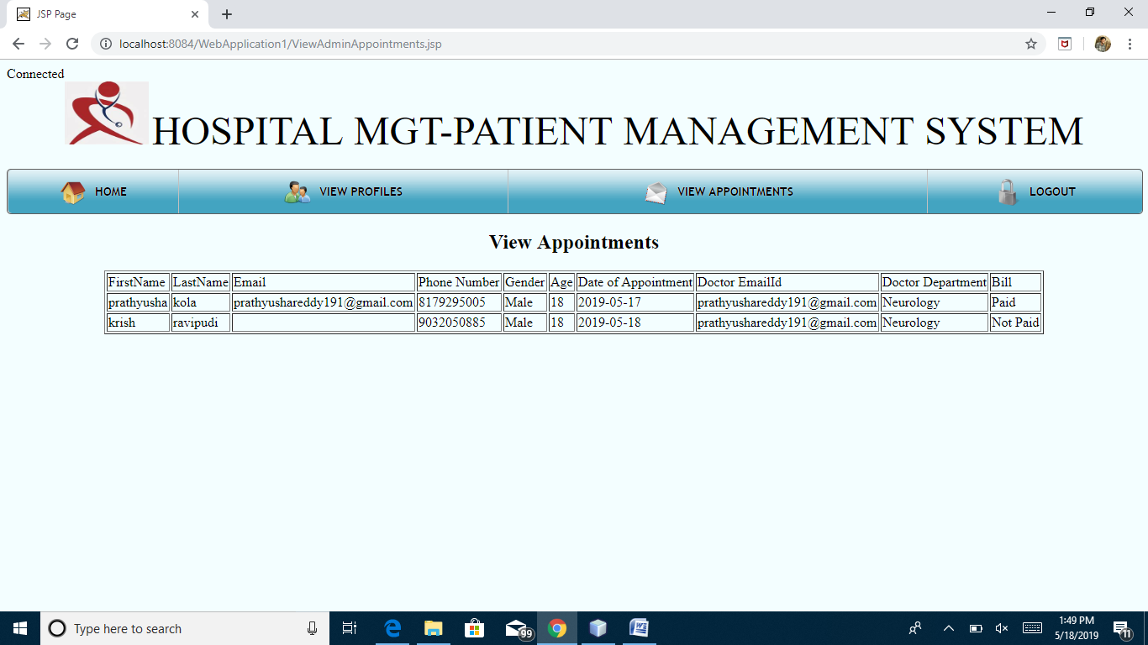

Fig:9.22 Admin View Appointments page for Hospital Patient Management system

**Admin forgot password:**

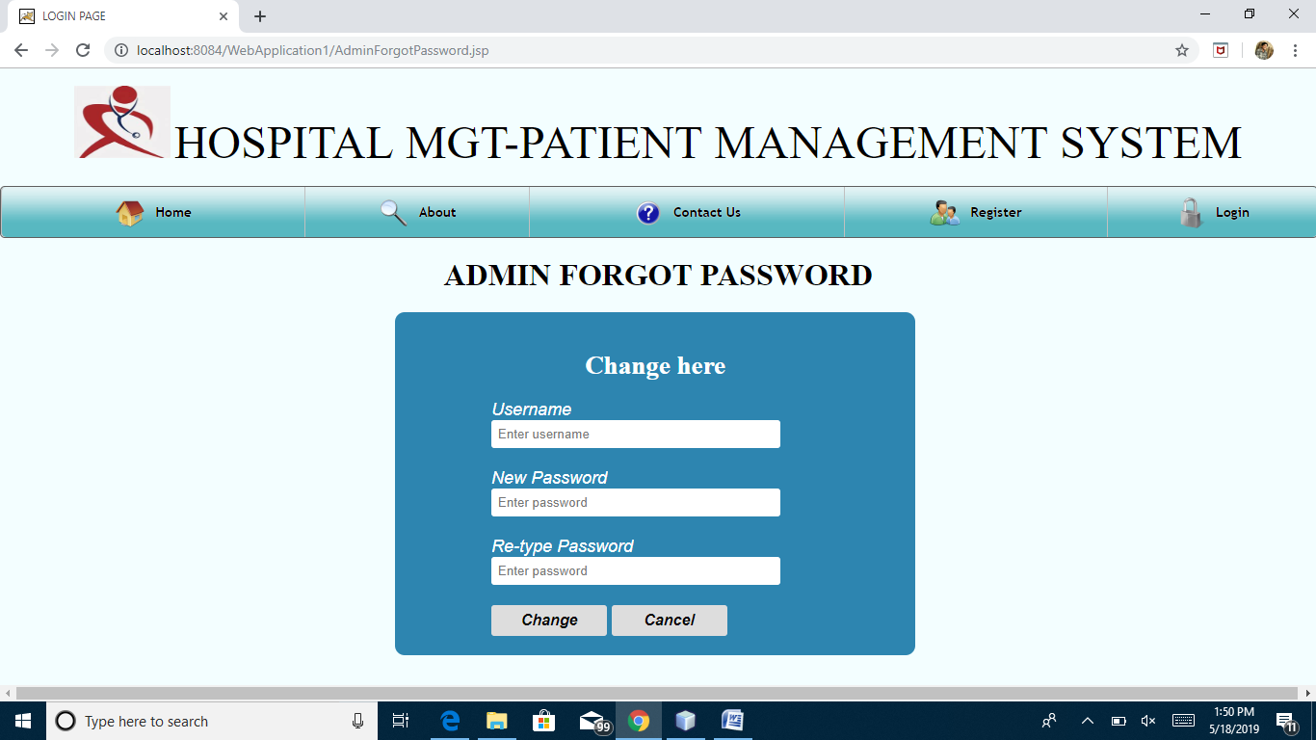

Fig:9.23 Admin Forgot Password page for Hospital Patient Management system

**10.DATABASE DESIGN**

**Admin Table**

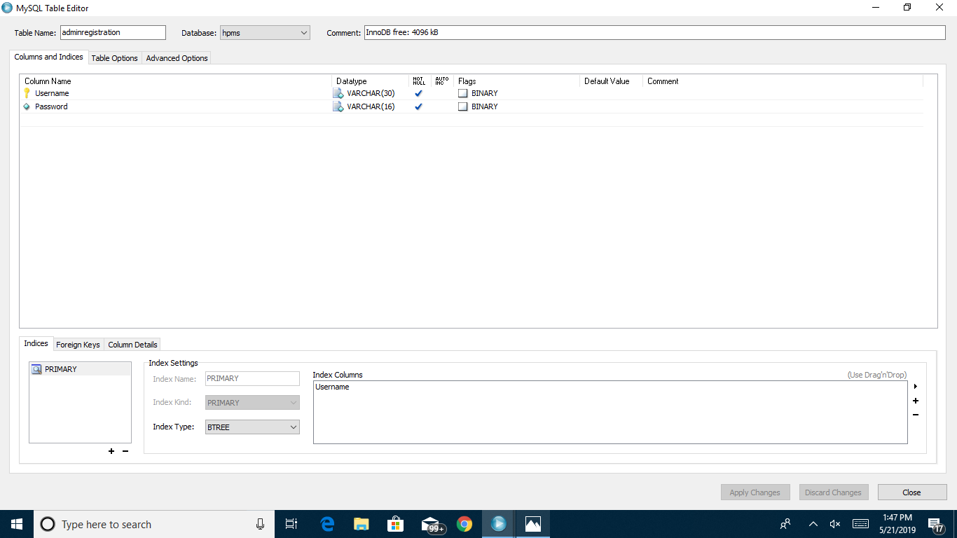

Fig:10.1 Admin Database Table for Hospital Patient Management system

**Appointments Table**

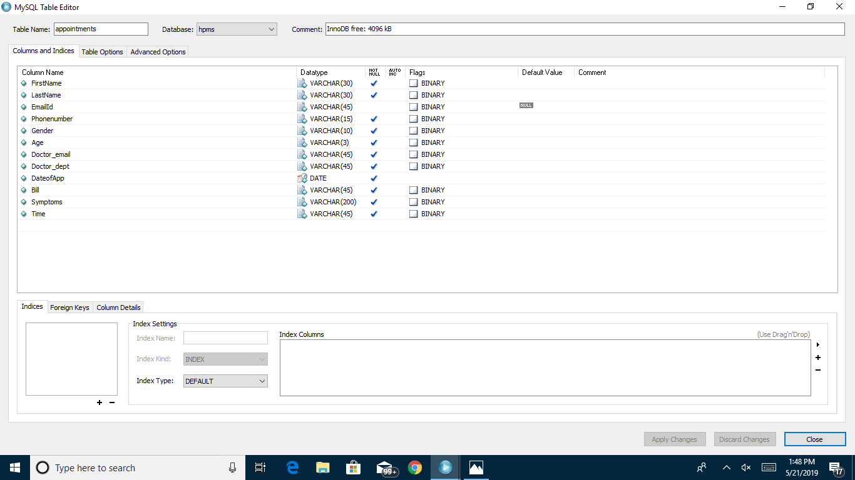

Fig:10.2 Appointments Database Table for Hospital Patient Management system

**Contact Us Table**

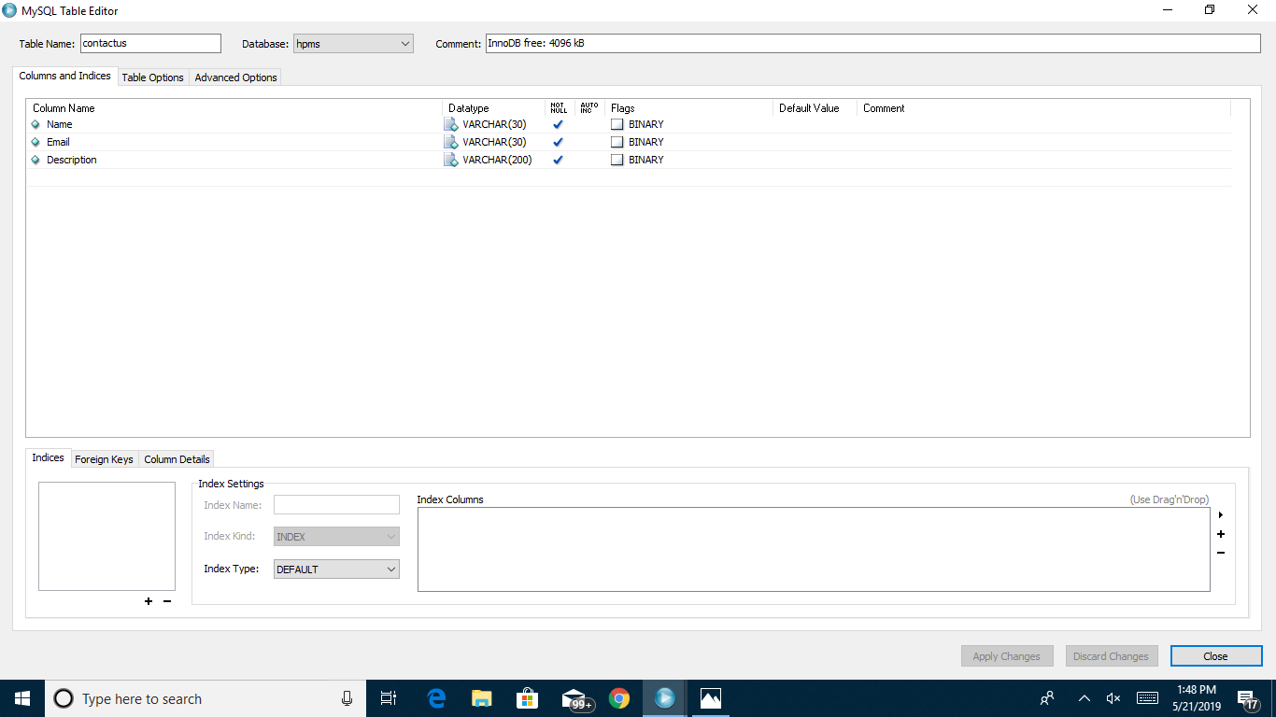

Fig:10.3 ContactUs Database Table for Hospital Patient Management system

**Doctor Prescription**

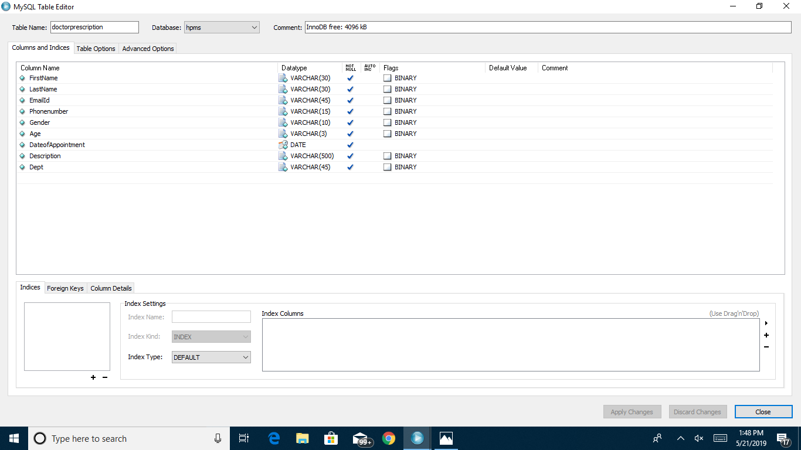

Fig:10.4 Doctor Prescription Database Table for Hospital Patient Management system

**Reception Registration**

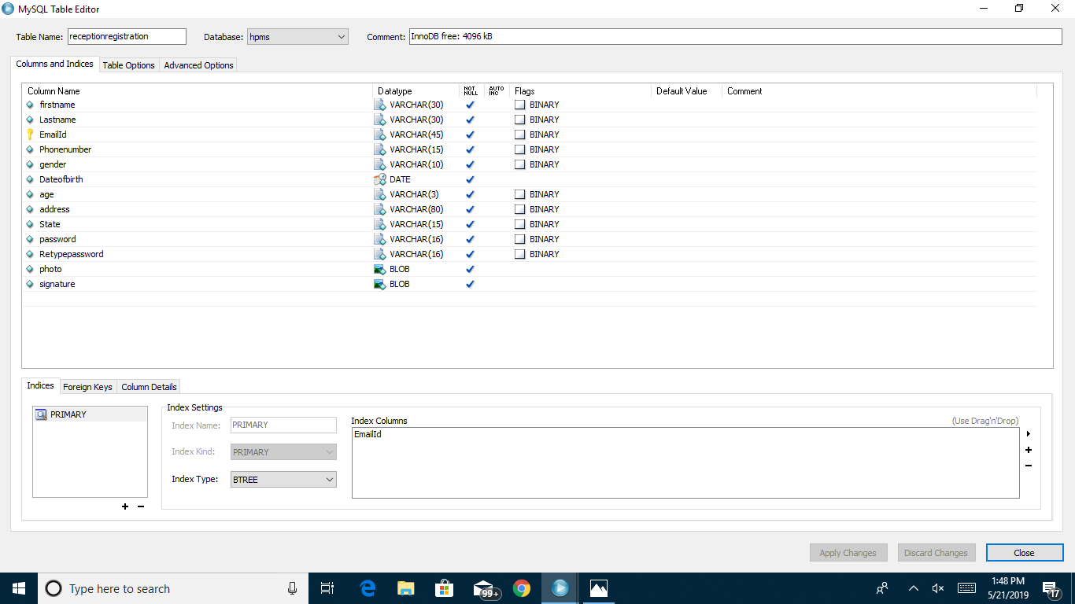

Fig:10.5 Reception Registration Database Table for Hospital Patient Management system

**Patient Registration**

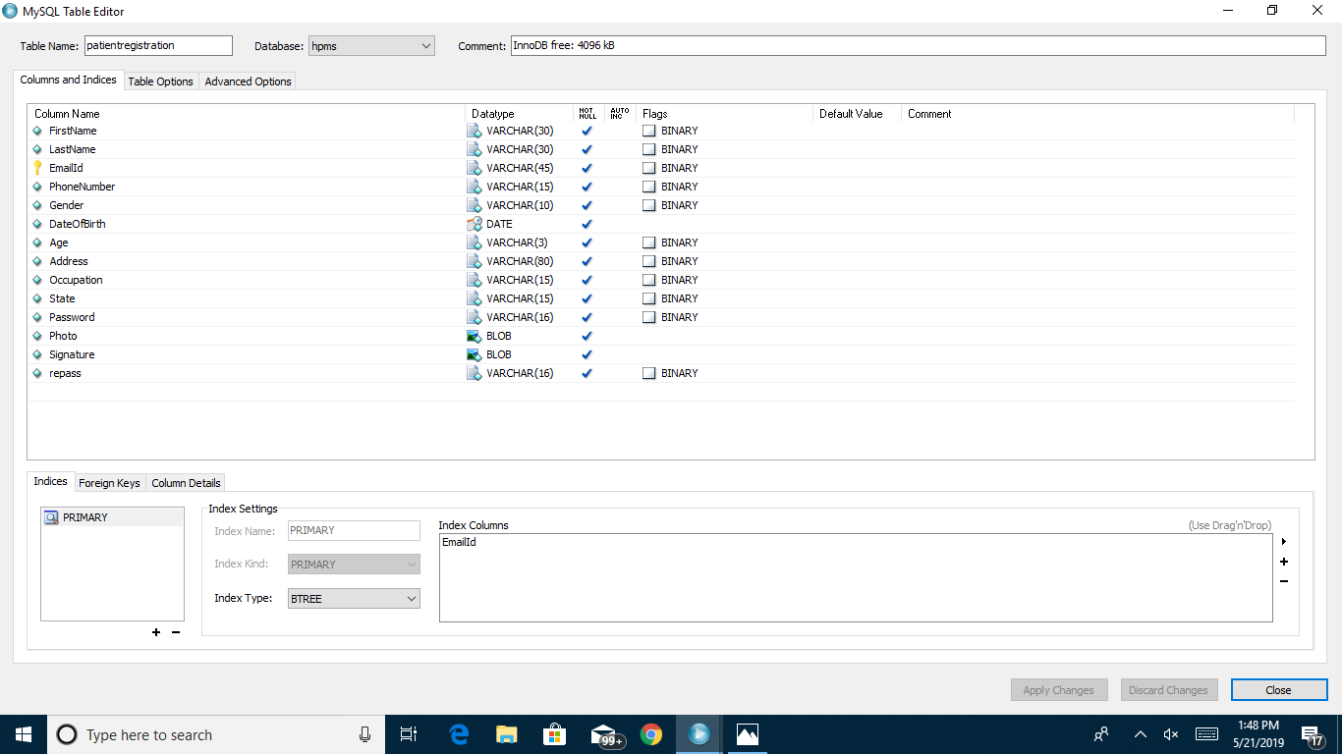

Fig:10.6 Patient Registration Database Table for Hospital Patient Management system

**Doctor Registration**

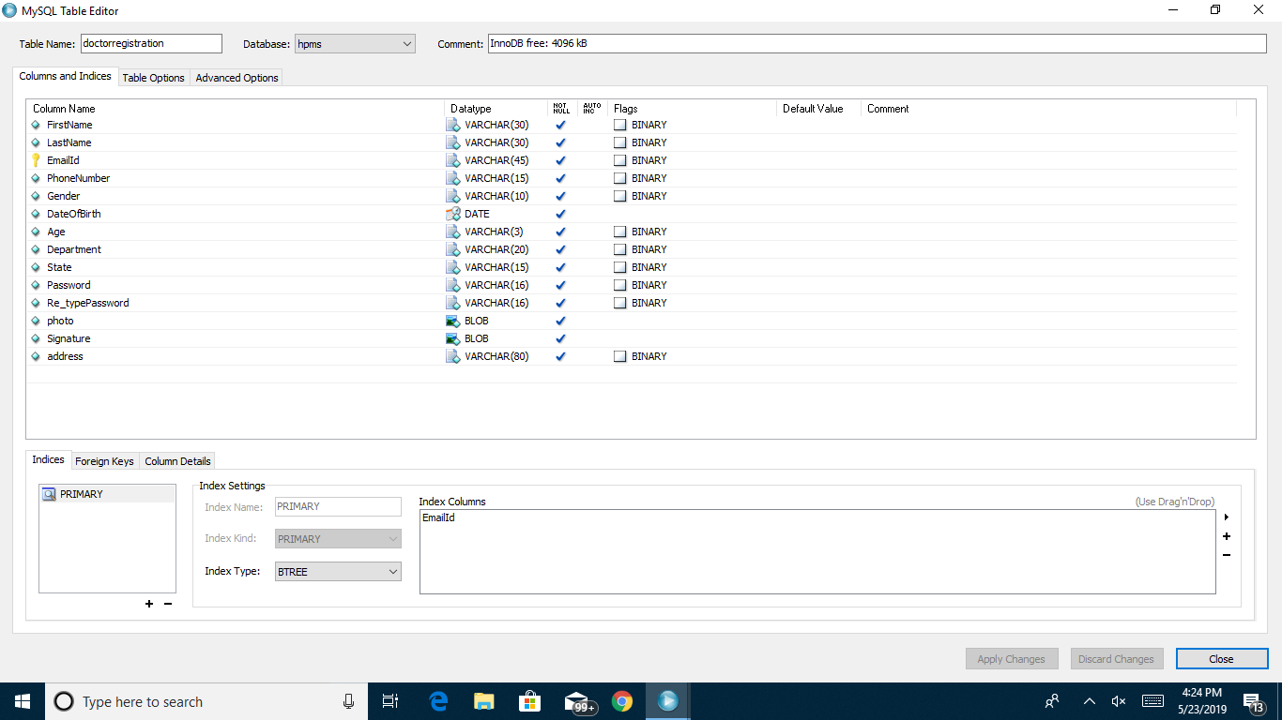

Fig:10.7 Doctor Registration Database Table for Hospital Patient Management system

**11.TEST REPORT & PLAN**

Testing is the process of detecting errors. Testing performs a very critical role for quality assurance and for ensuring the reliability of software. The results of testing are used later on during maintenance also.

**Psychology of Testing**

The aim of testing is often to demonstrate that a program works by showing that it has no errors. The basic purpose of testing phase is to detect the errors that may be present in the program. Hence one should not start testing with the intent of showing that a program works, but the intent should be to show that a program doesn’t work. Testing is the process of executing a program with the intent of finding errors.

**Testing Objectives**

The main objective of testing is to uncover a host of errors, systematically and with minimum effort and time. Stating formally, we can say,

* Testing is a process of executing a program with the intent of finding an error.

A successful test is one that uncovers an as yet undiscovered error.

* A good test case is one that has a high probability of finding error, if it exists.
* The tests are inadequate to detect possibly present errors.
* The software more or less confirms to the quality and reliable standards.

**Levels of Testing**

In order to uncover the errors present in different phases we have the concept of levels of testing. The basic levels of testing are as shown below…

Acceptance Testing

System Testing

Integration Testing

Unit Testing

Client Needs

Requirements

Design

Code

**System Testing**

The philosophy behind testing is to find errors. Test cases are devised with this in mind. A strategy employed for system testing is code testing.

**Code Testing**

This strategy examines the logic of the program. To follow this method we developed some test data that resulted in executing every instruction in the program and module i.e. every path is tested. Systems are not designed as entire nor are they tested as single systems. To ensure that the coding is perfect two types of testing is performed or for that matter is performed or that matter is performed or for that matter is performed on all systems.

**Types of Testing**

* **Unit Testing**
* **Link Testing**

**Unit Testing**

Unit testing focuses verification effort on the smallest unit of software i.e. the module. Using the detailed design and the process specifications testing is done to uncover errors within the boundary of the module. All modules must be successful in the unit test before the start of the integration testing begins.

In this project each service can be thought of a module. There are so many modules like Login, HWAdmin, MasterAdmin, Normal User, and PManager. Giving different sets of inputs has tested each module. When developing the module as well as finishing the development so that each module works without any error. The inputs are validated when accepting from the user.

In this application developer tests the programs up as system. Software units in a system are the modules and routines that are assembled and integrated to form a specific function. Unit testing is first done on modules, independent of one another to locate errors. This enables to detect errors. Through this errors resulting from interaction between modules initially avoided.

**Link Testing**

Link testing does not test software but rather the integration of each module in system. The primary concern is the compatibility of each module. The Programmer tests where modules are designed with different parameters, length, type etc.

**Integration Testing:**

After the unit testing we have to perform integration testing. The goal here is to see if modules can be integrated proprerly, the emphasis being on testing interfaces between modules. This testing activity can be considered as testing the design and hence the emphasis on testing module interactions.

In this project integrating all the modules forms the main system. When integrating all the modules I have checked whether the integration effects working of any of the services by giving different combinations of inputs with which the two services run perfectly before Integration.

**System Testing**

Here the entire software system is tested. The reference document for this process is the requirements document, and the goal os to see if software meets its requirements.

Here entire ‘ATM’ has been tested against requirements of project and it is checked whether all requirements of project have been satisfied or not.

**Acceptance Testing**

Acceptance Test is performed with realistic data of the client to demonstrate that the software is working satisfactorily. Testing here is focused on external behavior of the system; the internal logic of program is not emphasized.

In this project ‘Network Management Of Database System’ I have collected some data and tested whether project is working correctly or not.

Test cases should be selected so that the largest number of attributes of an equivalence class is exercised at once. The testing phase is an important part of software development. It is the process of finding errors and missing operations and also a complete verification to determine whether the objectives are met and the user requirements are satisfied.

**White Box Testing**

This is a unit testing method where a unit will be taken at a time and tested thoroughly at a statement level to find the maximum possible errors. I tested step wise every piece of code, taking care that every statement in the code is executed at least once. The white box testing is also called Glass Box Testing.

I have generated a list of test cases, sample data. which is used to check all possible combinations of execution paths through the code at every module level.

**Black Box Testing**

This testing method considers a module as a single unit and checks the unit at interface and communication with other modules rather getting into details at statement level. Here the module will be treated as a block box that will take some input and generate output. Output for a given set of input combinations are forwarded to other modules.

**TEST REPORT1:**

1. **Project Name:** Hospital Patient Management System

2. **Module Name:** login

3. **Unit Name:** User Name

4. **Test Result:** user-id and password is tested and verified.

**12. CONCLUSION**

Hospital Patient Management System is entry in to an area of information processing that is significantly different from existing ones. Because, of this fact a different approach to Hospital Patient Management System development and implementation is called for business engaged in launching or upgrading hospital patient management system must contain wide variety of factors that can influence activities.

Hospital Patient Management System make possible to simplify, improve & automate the hospitals activities as well as automatic transfer and exchange of information and management of administrative , handling numerical data without human operation.